Chapter 3
2. A variable of a primitive type directly stores data in its memory space, while a reference varaible stores the address of the memory space, where the data is stored.

4. The operator new allocates memory space of a specific type and returns the address of the allocated memory space.

a. Going
b. amusement
c. GOING TO THE AMUSEMENT PARK.
d. going to the amusement park.
e. Going *o *he amusemen* park.

8.
a. showInputDialog
b. showMessageDialog
c. JOptionPane
d. javax.swing

9. This statement causes the following input dialog box to appear that allows the user to enter the score.

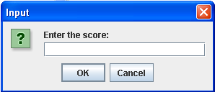
Figure F-1 Chapter 3 Exercise 9

10.

JOptionPane.showMessageDialog(null, "The sum of 2 and 3 = 5",
"Summing",
JOptionPane.INFORMATION_MESSAGE);
13.

x = console.nextInt();
ch = console.next().charAt(0);
y = console.nextInt();

