CSCI 204 Expression Tree Activity Prof Meng
Student name(s):
- Given the following expression trees, manually evaluate them. Show the steps similar to those in the lecture notes. Label the results b) through d) from left to right. a) is the example we did in the lecture notes.

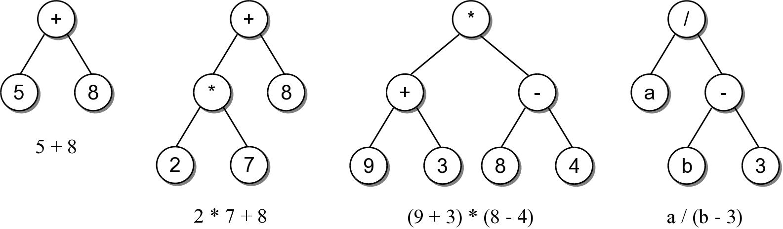

- Given the following fully parenthesized in-order expressions, manually build the expression trees following the examples in the notes. These expressions are in the program testexptree.py on the course website.
  - (1+2)
  - ((3+4)*(5-6))
  - (((3*5)+(2+4))+8)

- You should examine and run the programs about expression trees that are posted on the course website, in particular, make sure you understand the functions of building the tree from a given expression ( _build_tree() and its helper function _rec_build_tree()), as well as the function of evaluating a given expression tree ( _eval_tree())

